BE 1 Exercises

Exercise 1 (Network inspect)

<https://www.amazon.sa/>





Document, script, png,

Exercise 2 (Simple Node Server)

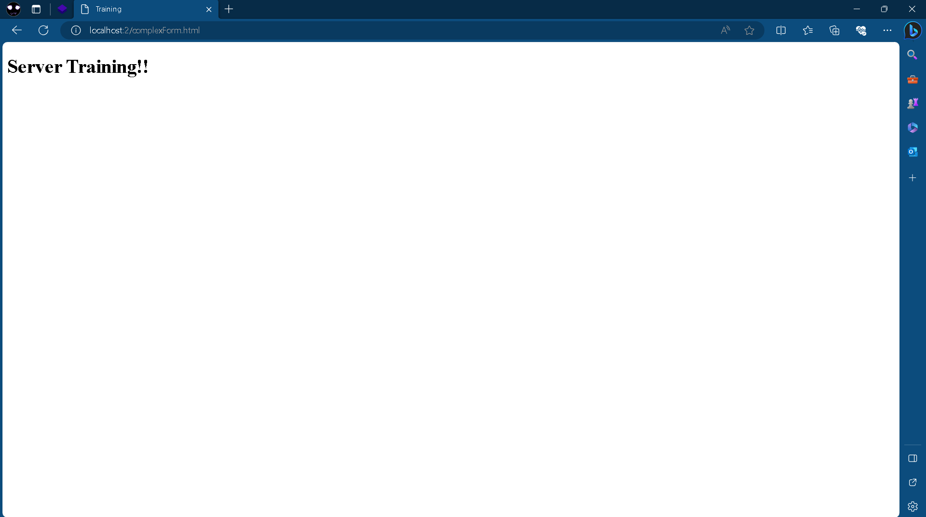

Exercise 3 (Domain Name)

